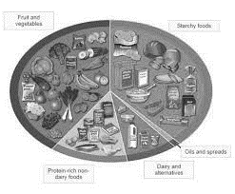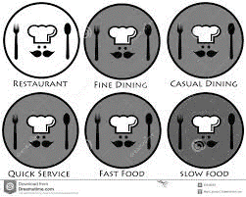

Sources and origins of paper and board

Introduction to the design brief

**Packaging Project**

Introduction to nets

Graphic design

Year 7 Knowledge Organiser

Name: _____________________

Class: ____________________

Teacher: ___________________

What is Graphic design?

Health and safety in the Graphics room

* 10 important facts test will take place 5 times throughout your time in this subject

Using CAD to create and investigation mood board

WA3 assessment exam

Sustainable materials

Shaping and forming of paper and board

Product evaluation

Design development and manufacture using CAD/CAM

The use of colour and typography to create logos

Analysing existing products

**7**

**YEAR**

**YEAR**

**7**

Investigating packaging symbols and labels

Isometric drawing techniques

Developing initial design ideas

**YEAR**

Hospitality: Types of restaurants

Food equipment and uses

Evaluation:

Spider diagram

Eat well guide

Health Diets: function of nutrients

Cooking Club

Food Hygiene rating task

Final WA assessment cook

Knife and Oven safety assessment

Customer service