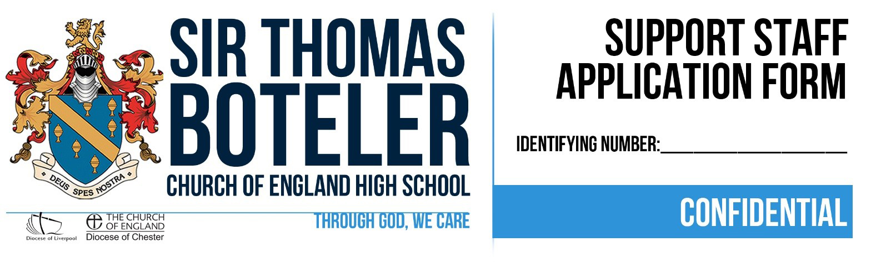

Sir Thomas Boteler Church of England High School is an equal opportunities employer. Please complete this application form in black ink or electronically. Please note that only fully completed application forms will be considered. Please do not attach your curriculum vitae.

As this post involves working with children any appointments will be subject to a DBS check at the enhanced level. Sir Thomas Boteler Church of England High School, as an aware employer, is firmly committed to safeguarding and protecting the welfare of children and vulnerable adults as a key priority.

Application for the post of:

This form must be returned to Mrs Jenny Muckley (PA/HR Manager) jmuckley@boteler.org.uk

By the closing date of:  Date received: | Interview date:  Post suitable for job share: Yes No

Personal details

NAME | Surname | Other Name(s) in full |  |  |  |  | Title
 | Known as: | Have you ever been known by any other name: If yes, please give details:
 | Previous surname:
ADDRESS | Address |  |  | Telephone Number(s)
 |  |  |  | Email Address
 | National Insurance Number | Do you require a work permit? If yes, what is the expiry date?
EDUCATION | School, College and/or University Attended |  |  | Grade/Qualification gained |  | Date From |  | Date To
TRAINING & PROFESSIONAL QUALIFICATIONS | School, College and/or University Attended |  | Grade/Qualification gained |  | Date From |  |  | Date To

Recruitment monitoring
Please tell us how you heard about this position: __________________________________________________________

Disability monitoring

Our school is positive about disability and is aware of the obligations arising from the Disability Discrimination Act 1995.

DISABILITY DEFINITION: “a physical or mental impairment which has a substantial and long term adverse effect on a person’s ability to carry out normal day to day activities”

If you have a disability and you meet the essential criteria of the employee specification, the school will guarantee you an interview.

Do you have a disability? Yes No

Please give brief details of your disability and of any workplace special adjustments or equipment that you may consider necessary to attend interview or to undertake the duties outlined in the job description.

_________________________________________________________________________________________________
_____________________________________________________________________________________________________________

EMPLOYMENT HISTORY – please highlight and explain any gaps in your employment
PRESENT APPOINTMENT
Title of present/most recent job: | Date appointed: | Date left if applicable:
Name and Address of Employer:

Telephone number: | Current salary or at time of leaving: | Permanent/Temporary:
Reason for leaving if already left:

What notice are you required to give? __________________________________________________________

OTHER EMPLOYMENT - Industrial, Professional, Commercial, etc.

From | To | Company | Position and Salary | Main Duties

TOTAL NUMBER OF DAYS OF ABSENCE IN THE LAST TWO YEARS
Date | Reason

PROFESSIONAL BODIES
Please give details of any professional body of which you are a Member. Indicate those obtained by examination.

DRIVING LICENCE DETAILS
Do you hold a full current driving license?

MEDICAL
Do you have any medical issues that may affect your ability to do the job? If yes, please give details.

Supporting Letter
Please attach a letter supporting your application for the applied post addressed to Mrs Scott-Herron (Headteacher).
The letter must be in Tahoma font, size 11 and no more than two sides of A4 in length.

DISCLOSURE OF CRIMINAL CONVICTIONS AND POLICE CLEARANCE
A criminal record will not necessarily exclude you from employment. The information provided will be treated strictly confidential and will only be considered in relation to the job for which you are applying.

You are required to disclose any unspent criminal convictions in line with the Rehabilitation of Offenders Act 1974. Certain posts require disclosure of criminal convictions, which are regarded as spent under the provisions of the Rehabilitation of Offenders Act (Exceptions) Order 1975. These posts include those working with children and vulnerable adults. If the post you have applied for involves working with children and/or vulnerable adults, a Disclosure and Barring Service (DBS) enhanced check will be required.

Do you have any unspent criminal convictions, cautions, reprimands or final warnings?

(you do not need to include cautions, reprimands or warnings which are over 5 years old)

Yes No

If “YES”, give details of offence and sentence: __________________________________________________________

I acknowledge that it is my responsibility as the candidate, if invited for interview, to disclose any information to the panel which may affect working with children/vulnerable adults.

Signed: _____________________________________________________________

Date: _______________________________________________________________

DECLARATION OF RELATIONSHIP
Are you or your spouse related by marriage, blood or as cohabitee to any member of the school governing body?

Yes No

If you are related, please give their name and state the relationship. Failure to disclose such a relationship may lead to disqualification or dismissal without notice.

Name: ________________________________________________________________________________________
Relationship: ___________________________________________________________________________________

If you canvass any employee of the school about your application, you may be disqualified. This does not stop a governor or employee giving a written reference about you.

SECTION 8 OF THE ASYLUM AND IMMIGRATION ACT 1996
Please refer to the enclosed guidance notes before answering these questions.
Do you have or are you entitled to obtain a National Insurance Number? Yes No

If you have answered “Yes” to the above question, please ensure that you have stated your National Insurance
Number on the front of this application form.

If you have answered “No” to the above question, do you have the right to work in the UK and can you provide the relevant requested information to prove that this is the case?
Yes No

REFERENCES REFERENCES WILL BE TAKEN UP FOR CANDIDATES WHO ARE SHORTLISTED
Without prejudice, have you any objection to your referees being approached prior to any interview?

Yes No

Please give the names and contact details of two people from whom references can be obtained about your suitability for the post applied for. One of these references should be a faith reference. This should be a cleric or minister from your place of worship. If one of your referees is not your current employer, whoever is making the reference request reserves the right to ask your current employer or head of institution for a confidential report.
If you are not currently working with children and/or vulnerable adults but have done so in the past, an additional reference should be supplied from the employer by whom you were most recently employed to work with children/vulnerable adults.

REFERENCE 1

Full Name & Title: | Position: |  | How they know the candidate:
Full address including postcode:

Email address: |  | Phone No: |  | Fax No:

REFERENCE 2

Full Name & Title: | Position: |  | How they know the candidate:
Full address including postcode:

Email address: |  | Phone No: |  | Fax No:

FAITH REFERENCE

Full Name & Title: |  | Place of Worship:
Full address including postcode:

Email address: | Phone No: |  | Fax No:

Interview attendance
Please indicate any periods when you may not be available for interview: ____________________________________
________________________________________________________________________________________________

DECLARATION
I certify that, to the best of my knowledge, all statements contained in this form are correct and I understand that should I conceal any material fact, I will, if engaged, be liable to termination of my contract of employment.

Signed: __________________________________________________________________________________________

Date: ___________________________________________________________________________________________

Providing false information is an offence and could result in the application being rejected, Summary Dismissal if the applicant has been selected and/or possible referral to the Teachers Misconduct Team or the Police, if appropriate. (Under the Education Act 2002 the employer has this statutory duty)

All offers of employment are subject to suitable references, qualifications check and satisfactory medical clearance, identity confirmation and DBS. If you require further information, please contact the school.

We must protect the public funds we handle, so may use the information you have provided to prevent and detect fraud. We may also share this information, for the same purposes, with other organisations which handle public funds.

We should like to take this opportunity to thank you for your interest in the advertised post. If you have not been contacted concerning your application within 4 weeks of the closing date, please assume you have not been short-listed for interview.

EQUAL OPPORTUNITIES AND MONITORING Identifying no: ____________________

Sir Thomas Boteler Church of England High School is striving to be an equal opportunities employer. As such we welcome applications from people of all backgrounds, irrespective of race, religious belief, ethnic and national origins, sex, marital status, disability, age or sexual orientation.

To assist us in monitoring the effectiveness of our policy, you are requested to provide the following information. The details you give will not be referred to during the shortlisting or interview process.

- Post applied for ______________________________________________________________________

- How would you describe your cultural origin? (please tick)

  - White
 | British |  |  |  |  | Irish |  | Any other White background
(B) Mixed
 | White & Black Caribbean |  |  |  |  |  |  | White & Black African
 | White & Asian |  |  |  |  |  |  | Any other mixed background
(C) | Asian or Asian British
 | Indian |  |  |  |  |  |  | Pakistani
 | Bangladeshi |  |  |  |  |  |  | Any other Asian background
(D) | Black or Black British
 | Caribbean |  |  |  |  | African |  | Any other black background
(E) Chinese or other ethnic group
 | Chinese |  |  |  |  |  | Other
4. Are you:
 | Male |  |  |  |  |  | Female
5. Are you currently employed?
 | Yes |  |  |  |  |  | No
6. Are you:
 | Married |  |  |  |  |  | Single
 | Divorced |  |  |  |  |  | Widowed
 |  |  |  |  |  |  | Separated

DATE OF BIRTH | / | /

