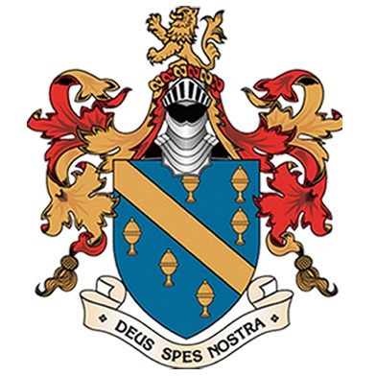
Extra-Curricular
Sport & Performance
(summer term 2017)

 | Lunch  1.20-1.50pm  (BALL HALL) | After School  3.00-4.15pm
Monday | KS4 Volleyball (CB)  All Years Table Tennis (Old Gym) | KS3 Rugby 9’s (AW)  GCSE PE REVSION ROOM 16 (CB/RH/JL)
Tuesday | KS3 TAG AMERICAN FOOTBALL (CB)  Table Tennis (Old Gym) | ALL YEARS TENNIS (CB)  ALL YEARS ROUNDERS (RH)
Wednesday | ROUNDERS  Table Tennis (Old Gym) | Department meeting night  BASKETBALL (COACH MARK)
Thursday | ALL YEARS TENNIS  Table Tennis (Old Gym) | ATHLETICS FIELD EVENTS (CB)  ALL YEARS CRICKET (AW)
Friday | INDOOR CRICKET (CB)  INTERHOUSE DODGEBALL (KH)  'SPOTLIGHT'(Drama Studio) | STRETCH & CHALLENGE REVISION 8AM (ROOM 16)  Staff Football  Super Fit Club  TENNIS 4-5PM

Students only requireD to wear trainers to lunch clubs, for all other after school clubs Sir Thomas Boteler full PE MUST be worn.

