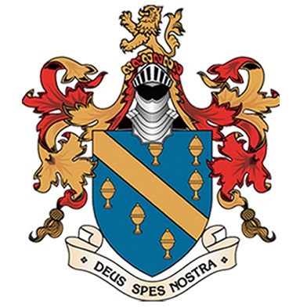
Extra-Curricular
Sport & Performance
(SPRING term 2017)

 | Lunch  1.20-1.50pm  (BALL HALL) | After School  3.00-4.15pm
Monday | KS3 HANDBALL (CB)  KS4 Badminton (RH)  All Years Table Tennis (Old Gym) | Y9 Rugby (AW)  Y7 netball (sport4all)
Tuesday | ALL YEARS Volleyball (CB)  ALL YEARS BaSKETBALL (RH)  Table Tennis (Old Gym) | Y7 Rugby – WARRINGTON WOLVES  KS4 HANDBALL (CB)  Trampolining (RH)  GCSE Drama Rehearsals (AA)
Wednesday | Girls TAG RUBGY (CB)  Netball Training (RH/AM)  Table Tennis (Old Gym) | All Years Football (CB/JL)  ALL YEARS ARCHERY (GYM)  Netball Fixtures (RH/AM)  Football Fixtures
Thursday | ALL YEARS DODGEBALL (RH/CB)  ALL YEARS INDOOR TENNIS  Table Tennis (Old Gym) | ALL YEARS GIRLS FOOTBALL (CB)  Y7 RUGBY (AW)  Y10 & Y11 Rugby  Y7 basketball – sports leaders  GCSE PE & DRAMA REVISION (ROOM 16)
Friday | KS4 Futsal (CB)  INTERHOUSE DODGEBALL (KH)  'SPOTLIGHT'(Drama Studio)  Table Tennis (Old Gym) | STRETCH & CHALLENGE REVISION 8AM (ROOM 16)  Table Tennis Team Training (AW)  LINKS Football (PP)  Staff Football  Staff Super Fit Club

Students only requireD to wear trainers to lunch clubs, for all other after school clubs Sir Thomas Boteler full PE MUST be worn.

