Thursday 12th January 2017
Dear Parents and Carers,
The proposal for Sir Thomas Boteler Church of England High School to form a Multi Academy Trust (MAT) called The Challenge Academy Trust.
We are consulting with you regarding the Governing Body’s proposal to form A Multi Academy Trust alongside the following institutions:
- Beamont Collegiate Academy
- Bridgewater High School
- Great Sankey Primary School
- Penketh High School
- Penketh South Primary School
- Priestley Sixth Form College
This follows an extensive period of due diligence and discussion by the Governing Bodies of all institutions including meetings with the Regional Schools Commissioner and the Department for Education.
Sir Thomas Boteler Church of England High School has always believed in working collaboratively with educational institutions similar in their outlook, vision, values and ethos for the aspirations and outcomes of young people. We are a school that stays true to its mission - ‘Through God We Care’ and our vision of High Expectations, High Aspirations and High Standards for all our students.
The government’s white paper Educational Excellence Everywhere published last year, echoes that ethos, recognising that Multi Academy Trusts are able in a more formal structure to bring together leadership, autonomy, funding and accountability across a group of schools with the purpose of mutual support.
Sir Thomas Boteler Church of England High School students deserve the enhanced educational, employment and capital investment opportunities that joining and helping shape TCAT will bring both now and long into the future.
I have been in constant contact with the Regional Schools Commissioners office following an Academy Order that was issued to the school in April 2016.
As you will be fully aware, our circumstances have changed considerably over the past two years and are now one of the most improved schools in the country. We feel that this opportunity would ensure that we continue to go from strength to strength, as well as enabling us to fully collaborate with other institutions to ensure the very best provision for the young people of Warrington. Due to our involvement in forming this MAT, we have a key role to play, especially due to our success in school improvement and as a Faith School.
We have been working very closely with the Diocese of both Chester and Liverpool to ensure that representatives from the Diocese would sit on both the Members and Trustees Board within the MAT, should the proposal go ahead. Our Faith status is very important and underpins our vision, values and ethos.
We have prepared a consultation document that is available on the website www.tcat.uk.com which provides more detail about this proposal, including our rationale and the potential benefits we feel this will have for staff and students at Sir Thomas Boteler Church of England High School. If you would like us to send you a hard copy, please ring the school and speak to Mrs Jackie Fletcher on 01925 636414 or email her at jfletcher@boteler.org.uk and we will send you a copy.
We would be very grateful if you could take the time to respond to the consultation by completing the on-line consultation proforma as your views are really important to us. Alternatively, please feel free to complete the proforma within the consultation document and return it to: The Clerk of Governors, Sir Thomas Boteler Church of England High School, WA4 1JL. The consultation period will begin on the 12th January 2017 and close at noon on the 9th February 2017.
In addition, we will be holding two Open Evenings to support the consultation process and you are welcome to attend either. We would appreciate it if you contact the respective school in advance should you wish to attend in the interests of managing numbers.
Monday 23rd January 2017 at 7:00pm

Bridgewater High School, (Upper School) Broomfields Road, Warrington, WA4 3AE
Contact: l.hyde@bridgewaterhigh.com

Monday 30th January 2017 at 7:00pm
Great Sankey Primary School, Liverpool Road, Great Sankey, Warrington WA5 1SB Contact: GreatSankey_Primary@warrington.gov.uk

Please do not hesitate to contact me if you have any specific queries. Many thanks as always for your continued support.
Yours sincerely,
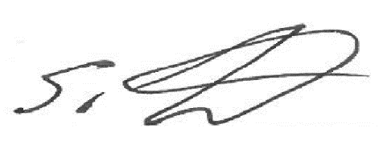
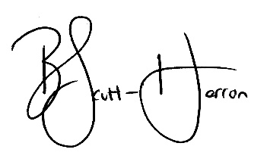
Beverley Scott-Herron Stuart Titchard
Headteacher Chair of Governors

